Legislative Council Staff
Nonpartisan Services for Colorado’s Legislature
Memorandum
January 14, 2026
To: Interested Persons
FROM: Samantha Lattof, PhD MSc, Science and Technology Policy Program Fellow
Brendan Fung, MPA, Fiscal Analyst
SUBJECT: Economic Impacts to Employers Providing Employee Health Programs and Health Insurance

Overview
This memo synthesizes evidence regarding the economic impacts of employer-funded health programs and insurance coverage on a company’s financial bottom line. Findings suggest that while interventions in chronic disease management, mental health, and occupational safety can generate positive returns on investment, the magnitude of these impacts remains highly sensitive to company size, program design, and methodological limitations like selection bias. Within the Colorado context, these health investments not only improve workforce productivity by reducing absenteeism and presenteeism but also contribute to regional fiscal stability by mitigating uncompensated care and commercial premium cost-shifting.

Introduction
Employees’ health impacts a company’s bottom line. Among companies providing employee health insurance and company health programs, this impact results in part from the direct costs required to provide these benefits. Employee health can also indirectly impact a company’s finances positively or negatively through mechanisms like reduced productivity due to employees being absent from work (absenteeism), reduced productivity due to ill employees performing at a lower level than when they are healthy (presenteeism), turnover, and workforce disruption.
Beyond financial inputs and outputs that can be measured or estimated in dollars, investments in employee health are linked to broader organizational outcomes like company/brand reputation and employee engagement and satisfaction. Health-supportive workplaces can improve morale. They may also enhance recruitment, investor perceptions, and customer goodwill.
While these various links and mechanisms can produce financial impacts that are large relative to a company’s direct health spending, the size and direction of net returns to an employer’s investment are context-dependent. What works in a 5,000-person company might not work in a 5-person company. The size and direction of financial impacts are also sensitive to program design, study methodology, and evaluation quality.
A 2021 study by Fabius and Phares found that the real-world stock market performance of an investment fund of publicly traded companies identified as promoting a “culture of health, safety, and wellbeing” outperformed peers in the S&P 500 on cumulative market returns. However, the study design cannot fully rule out selection bias, meaning companies that could afford such to implement best practices and health programs might already differ in performance.
Variation exists in the literature examining links between employee health, health insurance coverage, and financial impacts on companies. Systematic reviews and meta-analyses report positive findings for some workplace health programs, but they stress methodological limitations like:
- selection bias (e.g., healthier, more motivated employees participate in the programs);
- short follow-up windows;
- inconsistent definitions and economic measures, making economic analyses of programmatic costs and savings challenging across programs; and
- challenges with measurement, particularly for presenteeism.
High-quality studies find positive returns on investment for specific interventions, while other studies show modest or non-existent financial returns after applying rigorous controls. For this reason, developing robust conclusions requires using rigorous studies that carefully account for costs and are designed in ways that show credible causal relationships (e.g., randomized trials, strong difference-in-differences designs).

Net Returns to Employers Investing in Employee Health
Measuring the net return to employers from investments in employee health and health insurance requires an understanding of the various pathways by which investing in employee health can impact a company’s bottom line. Based on the diagram in Figure 1, the actual financial impacts of keeping people insured and healthy in the workforce will vary by:
- the specific health-related investments an employer chooses to make in its employees’ health, wellness, and safety;
- the magnitude of resulting improvements in employees’ health;
- the mechanisms by which employee health impacts job performance and the workplace; and
- the company-level outcomes one chooses to measure.
Figure 1
Pathway by which Investments in Employee Health Can Impact a Company’s Outcomes
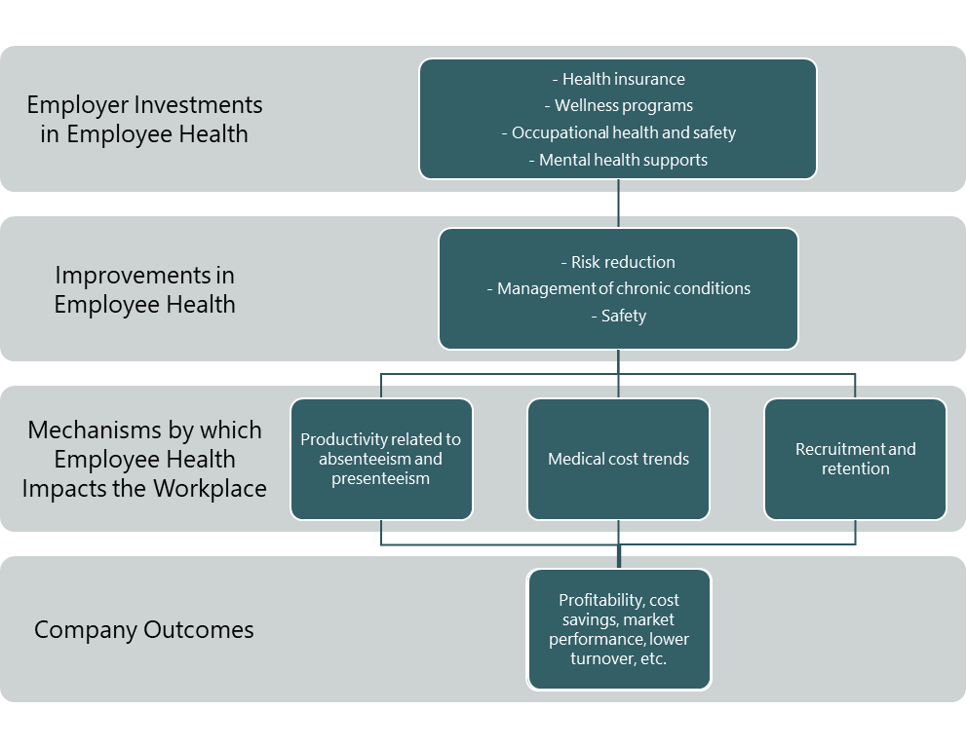
Source: Legislative Council Staff
Variables included in the green boxes in Figure 1 are examples of some of the most common topics from the literature. This list is not exhaustive and excludes impacts to company outcomes that are less frequently estimated in the literature (e.g., reputational outcomes, investor perceptions).
Due to the company-to-company variation that can occur throughout the pathway in Figure 1 and the multiple mechanisms by which employee health can impact the workplace, this memo defines the net impact to employers investing in employee health as:
Net employer impact =
direct savings + indirect savings - direct costs - indirect costs

Direct Savings
Direct savings are not always evident, especially when examining the short-term effects of a new investment in employee health. If incurred, direct savings may include:
- reductions in healthcare spending; and
- fewer employee sick days used.
Reductions in healthcare spending include lower premiums for employee health insurance and disability insurance premiums, lower workers’ compensation premiums, fewer injury claims, and reductions in medical costs. Reductions in medical costs are likelier when a company implements occupational health and safety programs and improves employees’ ability to manage chronic diseases (e.g., diabetes, cardiovascular disease). These savings would appear as fewer medical claims and a lower rate of employee visits to the emergency department, for example. They would be more directly accrued for self-insured employers.

Indirect Savings
Companies could calculate indirect savings by measuring mechanisms by which employee health impacts job performance. These indirect savings could include reductions to:
- absenteeism;
- presenteeism; and
- turnover/hiring resulting from ill employees leaving the company or being out on medical or disability leave.
While quantified tools exist to map health status to productivity loss resulting from absenteeism and presenteeism, reduced productivity is more frequently measured in the scientific literature when it focuses on well-studied conditions (e.g., cardiovascular disease, cancer, depression).
Companies can calculate savings from reduced turnover and hiring by applying benchmark costs to a company’s data on employees leaving for health reasons or by obtaining estimates directly from the human resources department. Reductions to turnover can also benefit companies in financially intangible ways (e.g., retainment of institutional knowledge) beyond the scope of this memo.

Direct Costs
A company’s direct costs would include the specific investments the company made in employee health and wellness, such as payment of direct health-related benefits like:
- employer premium contributions;
- investments in occupational health and safety;
- employee health and wellness programs (e.g., mental health supports, health-related benefits); and
- expected per-employee claims.
Companies contemplating investing in employee health can estimate their direct costs using data from KFF to estimate employer premium contributions and data from the Colorado All-Payer Claims Database to estimate per-employee health claims.

Indirect Costs
Indirect costs are beyond the scope of this memo but could include expenses such as:
- staff time to manage/administer programs;
- promotional materials;
- program communication;
- in-house IT costs; and
- program monitoring and evaluation expenses.

Economic Impacts to Companies Investing in Employee Health Programs and Health Insurance
While the model above outlines the ways by which investments in employee health can impact a company’s outcomes, this section focuses specifically on evidence-based financial impacts to companies implementing employee health programs and offering employee health insurance. These impacts include direct financial costs and financial estimations of pathways that influence a company’s productivity (e.g., absenteeism, presenteeism, turnover). Financially intangible impacts of investments in employee health, like improved company morale and increased job attractiveness, are beyond the scope of this memo.

Impacts Resulting from Investments in Employee Health Programs
For the purposes of this memo, employee health programs include evidence-based programs covering:
- management of chronic diseases;
- mental health; and
- occupational health and safety.
Employee health programs, discussed in greater detail below, impact a company’s finances by:
- reducing costs of employee injury and worker’s compensation claims;
- reducing costs of short- and long-term disability and medical leave;
- reducing healthcare costs (particularly high-cost claims) and thus health insurance premiums;
- decreasing the number of sick days used;
- improving employee productivity and reducing absenteeism/presenteeism;
- reducing turnover; and
- producing positive returns on investment.

Management of Chronic Diseases
The Integrated Benefits Institute estimates that chronic diseases (e.g., diabetes, cardiovascular disease, hypertension, cancer) and injuries cost American employers over $575 billion annually due to absenteeism, presenteeism, short-term disability, long-term disability, family and medical leave, and workers compensation. Chronic health conditions cost employers an estimated $3,918 per employee in lost productivity costs in 2019.
Studies find that better management of chronic diseases leads to reductions in risk factors (e.g., reduced blood pressure, controlled blood sugar), though their financial impacts on employer medical costs and employee productivity vary. This variation exists in part because studies do not use standardized measurements for absenteeism, productivity, and presenteeism. With researchers using different definitions and measures, the results can be difficult to compare across studies.
A 2010 meta-analysis by Baicker and colleagues examined workplace disease prevention and wellness programs aimed at improving employees’ health and reducing employers’ costs. Most (90 percent) of the programs in their analysis reported findings from large firms with over 1,000 employees. Four in five studies reported on employee health risk assessment surveys as an initial intervention or as a requirement for participating in a health program. Other common interventions for employees included offering self-help materials (40 percent), individual counseling (40 percent), and on-site group activities like classes or seminars (35 percent). Workplace programs most commonly focused on obesity and smoking.
Across studies that reported returns on investment (ROIs), Baicker and colleagues found that interventions costing employers an average of $144 per employee per year produced an average savings of $358 per employee per year in reduced health costs. Across the 22 studies reporting on employee absenteeism, workplace interventions costing an average of $132 per employee per year returned savings of $294 per employee per year (based on an average hourly wage of $20.49). For every dollar that companies spent on employee health programs, employee healthcare costs decreased by $3.27 on average, and absenteeism costs decreased by $2.73 on average. Baicker and colleagues concluded that large employers implementing employee health programs are likely to see “substantial positive returns, even within the first few years after adoption.”

Mental Health
Depression decreases employees’ work productivity through absenteeism and presenteeism. Among employees with depression, company losses range from $10,655 to $13,080 per person in mean annual adjusted productivity depending on the type of health insurance (Zhdanava et al. 2021). Companies that promote mental health and support the mental health of their employees are likelier to increase productivity and reduce absenteeism and presenteeism.

Additionally, investing in workplace mental health programs can produce positive ROIs. Workplace interventions focused on mental health prevention can be cost-saving, returning $1.5 to $7 per dollar invested (Le et al. 2021). A 2002 systematic review by de Oliveira and colleagues revealed moderate-strength evidence that workplace interventions involving cognitive behavioral therapy (CBT) and care management for treating employee depression provide positive employer ROIs. Based on the intervention, companies implementing these programs experienced ROIs ranging from $1.78 to $3.35 per employee after one year.
A 2017 systematic review and meta-analysis by Carolan and colleagues examined findings from 21 randomized controlled trials of digital mental health interventions for employees. Over half of interventions focused on CBT or cognitive therapy. These digital interventions delivered in the workplace produced small but significant effects on employee wellbeing and work effectiveness. However, the researchers did not attach a cost or savings to their findings.

Occupational Health and Safety
Poor employee health and safety cost American employers over $58 billion in workers’ compensation costs resulting from serious, non-fatal workplace injuries in 2018. Work-related injuries also cost employers 103 million days lost in 2023 and an estimated $15.7 billion in uninsured costs, such as lost time by non-injured employees who were directly or indirectly involved in the incident, personnel time required to investigate and write up reports, and other administrative tasks.
Systematic reviews find that targeted injury-prevention programs and ergonomic interventions show more consistent economic gains than broad wellness programs or psychosocial interventions. Due to weaker study designs and inconsistent measures and definitions for productivity, it is difficult to assess the complete costs of many interventions.
A 2009 systematic review by Tompa and colleagues examined the financial merits of 72 occupational health and safety interventions across 12 industry sectors. They grouped these interventions into six categories:
- ergonomic and musculoskeletal injury prevention interventions (the most common type of intervention);
- disability management interventions (the second most common type of intervention);
- occupational disease prevention interventions;
- multi-faceted (two or more) interventions;
- health promotion interventions; and
- interventions to reduce violence in the workplace.
While the researchers classified their findings by industry and intervention, strong evidence exists for disability management interventions across industries. Strong- to moderate-strength evidence exists across industries for ergonomic and musculoskeletal injury prevention interventions. Based on economic analyses, the authors conclude that such interventions are worthwhile. However, the financial impacts are not standardized or quantified across studies.
Drawing upon published business case studies and case reports, Verbeek and colleagues conducted a systematic review in 2009 to assess if cost-benefit analyses support occupational health and safety programs from health and productivity angles. Of the 26 cases included in their study, three cases estimated the future impact of an investment decision (to implement an intervention) and 23 cases described the impact of a past investment decision. Most cases involved an ergonomic intervention (n=19) to prevent musculoskeletal pain or injury or to automate heavy physical labor. About three in four interventions were profitable, with the benefits paying back the costs of the intervention within one year. Table 2 in their paper details the intervention costs, benefits, and consequences in Euros. Financial consequences of interventions included:
- avoided sick leave;
- avoided medical cost;
- avoided other cost;
- productivity increase; and
- quality increase.

Impacts Resulting from Investments in Employee Health Insurance
Providing employee health insurance, discussed in greater detail below, impacts a company’s finances by:
- improving employee productivity and reducing absenteeism/presenteeism;
- increasing retention and reducing turnover, lowering recruitment and replacement costs;
- reducing medical expenditures (e.g., high-cost claims);
- offsetting wages;
- decreasing the number of sick days used;
- enabling the adoption of cost-reducing health insurance strategies (e.g., managed care, negotiated pricing); and
- producing positive returns on investment.
Illness-related productivity losses cost American employers an estimated $530 billion annually (IBI 2018). Employees who experience financial barriers to care experienced 70 percent more sick days than employees without financial barriers, according to a 2019 study by the Integrated Benefits Institute.
Academic literature shows a well-established relationship between health insurance and increased access to preventative and chronic healthcare. Health insurance not only improves access to care, but it also reduces unmet need for care.
Improved access to care makes it easier for employees to obtain preventative healthcare services, seek early treatment, adhere to their medications, and manage their chronic diseases more effectively. As a result, expensive acute care is likely to be reduced in the future, helping keep employer-sponsored health plan costs from skyrocketing. Additionally, employees with chronic conditions may miss fewer days when they can access timely care and better manage their health conditions.
Employees with health insurance and paid sick leave are likelier to take off time when ill or injured than employees without these benefits (Stimpson et al. 2025). However, the existence of these benefits does not mean employees in lower-wage or part-time positions will use them. Some employees might experience structural barriers (e.g., scheduling issues) or cultural barriers (e.g., workplace norms, perceived or actual employer retaliation) to using these benefits.

Employer-Sponsored Health Insurance
Systematic reviews examining employer-sponsored health insurance are limited. Weinmeyer and colleagues conducted a systematic review in 2021 to analyze employer-led efforts to improve the value of health spending. The 44 resulting studies reported data on employer health spending and employee health outcomes within three categories of benefit changes:
- restructuring drug benefits (n=27);
- redesigning payment models or health plans (n=10); and
- promoting access to high-value services (n=7).
About three in five studies reported improved value, meaning that the interventions reduced employer health spending without compromising employee health outcomes, improved employee health outcomes without raising employers’ costs, or improved across both outcomes. While the authors consider these efforts “likely worthwhile” for companies to implement, they remind readers that variations in results may stem from differences in employees, employers, benefit design details, and study quality. They conclude by recommending that employers consider finding opportunities for lowering cost sharing for high-value services.

Colorado-Specific Research Findings
Turning to research specifically from Colorado, researchers from Colorado School of Public Health, the University of Colorado, and partner organizations examined how employee health, job demands, and workplace safety predict absenteeism and presenteeism (Jinnett et al. 2017). Analyzing data from Pinnacol Assurance on 16,926 employees across 314 large, midsize, and small businesses in Colorado, they found that employees struggling with chronic health conditions or prior workplace injuries missed more work (greater absenteeism) and were less effective when on the clock (greater presenteeism) than workers without these characteristics. These findings were particularly pronounced for workers in physically and cognitively demanding roles.

Additionally, the researchers estimated predicted costs of absenteeism and presenteeism per person year by job difficulty, the presence of chronic conditions, and the existence of workers’ compensation claims. To help Colorado businesses keep their workforce healthy, present, and productive, the researchers recommended supporting integrated workplace programs that address employee health, safety, and improved alignment between employees’ abilities and job demands.
Building on this research, Schwatka and colleagues examined the impact of worksite wellness programs by business size (2018). Their three-year observational cohort study of 5,766 employees from the 314 companies in Colorado found that small-business employees were likelier to participate in worksite wellness programs than large-business employees. While the researchers did not observe changes in absenteeism or presenteeism, they found that small-business employees experienced more health improvements (i.e., improved overall health, reduced depression, reduced smoking, increased fruit consumption, greater physical activity) than large-business employees (i.e., reduced alcohol consumption). Employees from both large and small businesses experienced improvements in stress and vegetable consumption.
Given the links between managing employee health risks, productivity, healthcare costs, and employee safety, Pinnacol Assurance and the Centers for Health, Work & Environment at Colorado School of Public Health developed an online calculator (towards the bottom of the webpage) for companies to find out how much their organization could save by investing in worker health and safety (Schwatka et al. 2020).

Colorado-Specific Financial Considerations for the Health and Business Landscapes
In 2023, 52.2 percent of Colorado residents received health insurance coverage from their employer, 18.7 percent were enrolled in Medicaid or Child Health Plan Plus (CHP+), and 6.7 percent were uninsured (KFF 2023). The remaining 22.4 percent of the population received health insurance through a number of alternative programs. For single-person coverage, large employers in the state pay an average premium of $6,462 for employee-sponsored plans, as compared to the national average of $6,697 (KFF 2024). Medicaid, on the other hand, costs the state about $6,590 for the average adult enrollee (KFF 2025).
From a state perspective, a number of scenarios and factors may dictate the financial impact of insured employees on Colorado’s large employer market and the overall budget landscape.

Direct State Expenditures
When workers have stable health coverage — whether through employer-sponsored insurance, Medicaid (Health First Colorado), CHP+, or the individual marketplace — they tend to use healthcare earlier and more appropriately. Insured individuals experience fewer avoidable emergency department visits and hospitalizations, which are substantially more costly than primary or preventative care. In Colorado, the cost of an emergency visit without insurance can range from hundreds to tens of thousands of dollars.
Access to primary care through insurance, on the other hand, can range from no copay to a few hundred dollars depending on plans. For the state, insurance reduces uncompensated care burdens that often trigger supplemental payments or other state-supported financing mechanisms intended to stabilize hospitals and safety net providers. Coverage also decreases churn, which lowers administrative reprocessing costs and improves continuity of care, which directly reduces program expenditures over time.

Indirect System Pressures
Insurance coverage also influences broader workforce dynamics. Insured workers are absent less often, remain healthier on the job, and exhibit higher levels of productivity. For large public employers, such as school districts, counties, and state agencies, these dynamics are important. Reduced turnover means fewer resources spent on hiring, onboarding, or retraining. Conversely, uninsured workers are more likely to experience destabilizing health events that lead to missed work, job loss, or long-term disengagement from the labor force. Once unemployed, individuals often turn to state-funded or state-administered services, including unemployment insurance, SNAP, behavioral health systems, and housing support. In this way, lack of insurance indirectly increases demand on a range of state safety net programs.
The indirect impacts extend to the healthcare system as well. Uninsured workers who delay care frequently cycle through emergency departments, which leads to higher uncompensated care. Hospitals respond by shifting costs onto commercial payers, driving up premiums for employers across the state. Rising premiums affect school districts, local governments, and the state as an employer, thus increasing total compensation costs and reducing the resources available for other priorities.

State Revenue Effects
Healthcare coverage also has revenue implications. More productive employees may generate greater business income, contributing to state corporate income and sales and use tax revenue. Workers who maintain steady employment and who are not destabilized by unexpected medical expenses tend to earn more over time, increasing personal income tax collections as well. Insurance also reduces the fiscal volatility associated with medical debt, bankruptcy, and workforce withdrawal, which indirectly stabilizes Colorado’s revenue streams.
At the systems level, lower uncompensated care can moderate cost-shifting, relieving pressure on commercial premiums and allowing employers to retain a larger share of income that flows back into the state economy through taxable activity.

Administrative and Workforce Effects
Finally, insurance coverage shapes the administrative workload and financial responsibilities of state agencies. Medicaid and CHP+ represent significant state expenditures for eligibility determination, enrollment processing, and medical services. Marketplace enrollees who qualify for subsidies also draw from the Health Insurance Affordability Enterprise (HIAE) Fund, increasing enterprise spending. However, coverage reduces uncompensated care burdens that would otherwise require supplemental payments or public subsidies to maintain hospital solvency.
Coverage also interacts with other agency functions. Stable insurance reduces strain on county human services offices, behavioral health crisis systems, corrections health services, and state-funded community providers. Fewer emergency events, lower uncompensated care, and reduced workforce turnover all translate into fewer administrative tasks for eligibility workers, case managers, human resource units, and program administrators.

Systematic reviews are one of the strongest forms of health research. To produce this objective and reproducible research, researchers methodically collect all evidence on a topic, filter the evidence with pre-defined criteria, and analyze the resulting studies to answer a specific research question.
Meta-analyses are also one of the strongest forms of health research. These analyses involve combining quantitative data (findings) from multiple studies, where and when possible, to produce a single synthesis of the results. This method enables researchers to make stronger and more reliable conclusions.
Their Health Affairs article is paywalled, but a PDF is available for download via Google Scholar.
Their Lancet article is paywalled, but the authors made a pre-print available for download.
The authors evaluated the strength of evidence using an established approach that looks at the quality, quantity, and consistency of available evidence. Evidence is ranked as strong (three or more studies report consistent findings), moderate (two studies report consistent evidence), limited (findings are available from only one study), or mixed (studies report contradictory findings).
The Journal of Occupational and Environmental Medicine has paywalled this article, but the authors made their study papers available on the project website.
The authors evaluated the strength of evidence using an established approach that looks at the quality, quantity, and consistency of available evidence. Evidence is ranked as strong (three or more studies report consistent findings), moderate (two studies report consistent evidence), limited (findings are available from only one study), or mixed (studies report contradictory findings).
This article is paywalled, but one of the authors posted an open-access copy on their ResearchGate page.
While the Small Business Administration considers “small businesses” to be those with under 500 employees, researchers analyzed employee data for four categories: businesses with <50 employees, with 50-99 employees, with 100-499 employees, and with 500+ employees.

